Nama : Muhamad Nur Alim

NIM : 18090040

Kelas : 5B

**Laporan Pratikum 3**

1. Source Code

Data-form-matakuliah.php → view

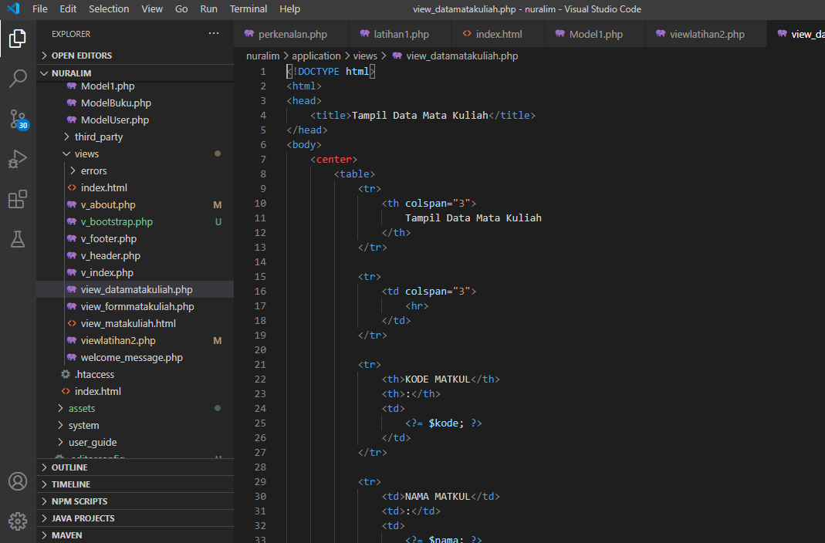

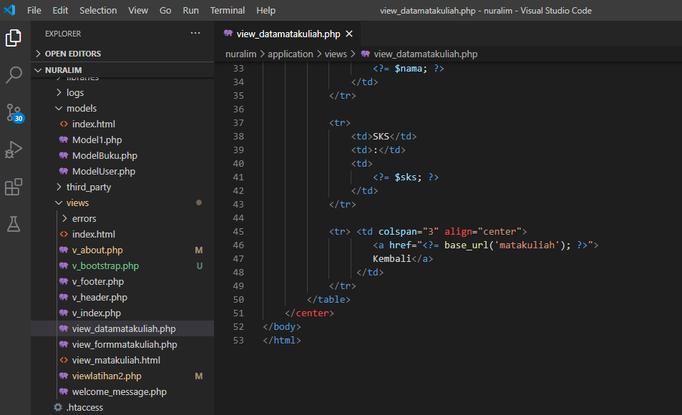

View-form-matakuliah.php → view

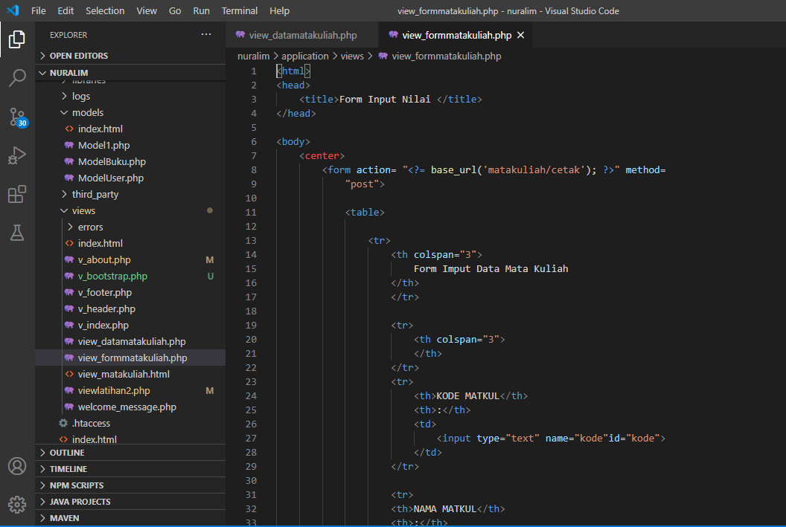

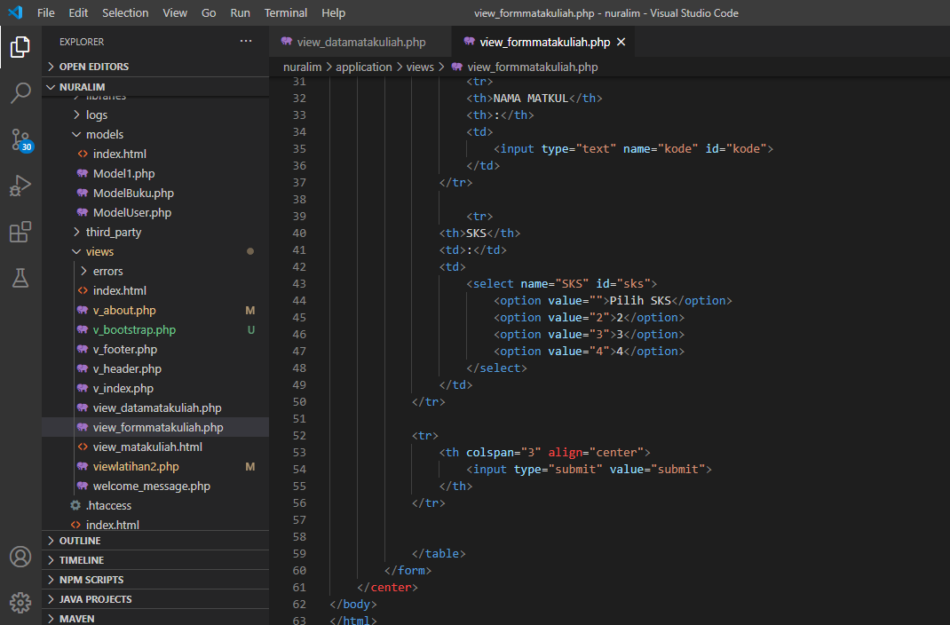

Matakuliah.php → controllers

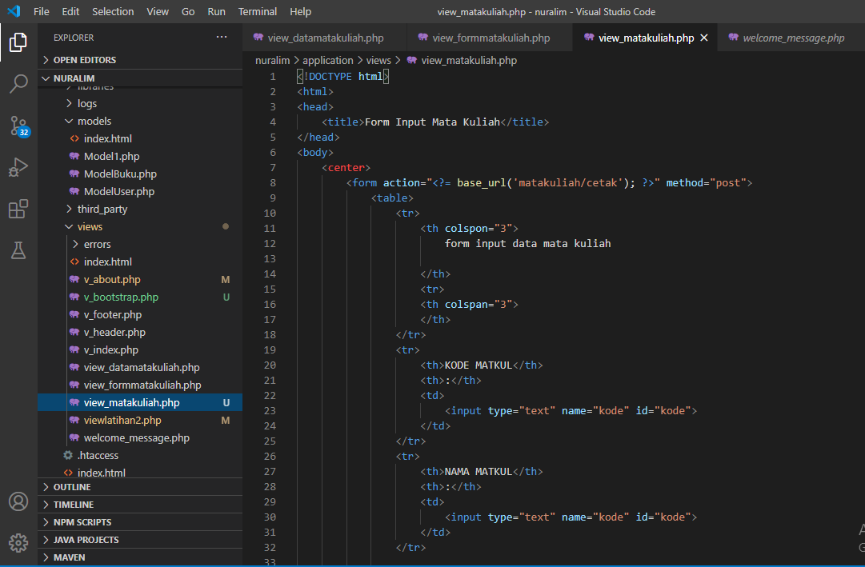

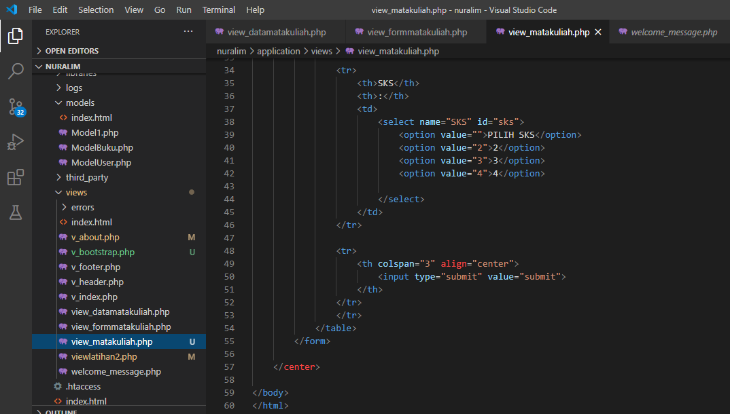

1. Capture Output Program

